ITESO - Maestría en Sistemas Computacionales

Asesor: J. Guadalupe Olascuaga Cabrera

Co asesor: Luis Fernando Gutiérrez Preciado

Alumno: Mawrer Amed Ramirez Martinez

Reporte de Avance de Trabajo de Obtención de Grado

Asesoría: 30 octubre de 2019

**Avance Presentado:**

En Base a un ejemplo de RNN encontrado donde utiliza LSTM se presenta el modelo utilizando los datos EUR/USD con un hiper parámetro de 60

**Trabajo para la siguiente sesión:**

**Notas:**

#### What is RNN

Ref- <https://colah.github.io/posts/2015-08-Understanding-LSTMs/>

Download Dataset- <https://finance.yahoo.com/quote/GOOG/history/>

Recurrent Neural Networks are the first of its kind State of the Art algorithms that can Memorize/remember previous inputs in memory, When a huge set of Sequential data is given to it. Recurrent Neural Networks are the first of its kind State of the Art algorithms that can Memorize/remember previous inputs in memory, When a huge set of Sequential data is given to it.

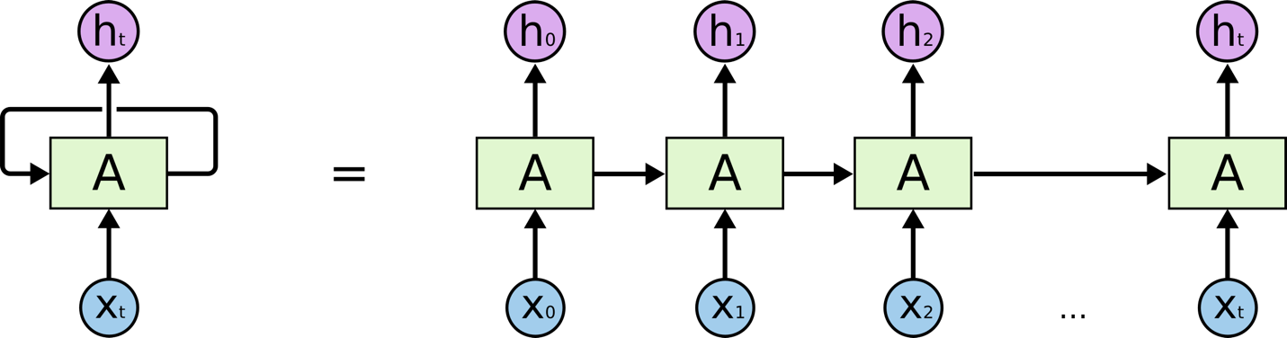

These loops make recurrent neural networks seem kind of mysterious. However, if you think a bit more, it turns out that they aren’t all that different than a normal neural network. A recurrent neural network can be thought of as multiple copies of the same network, each passing a message to a successor.

#### Different types of RNN’s

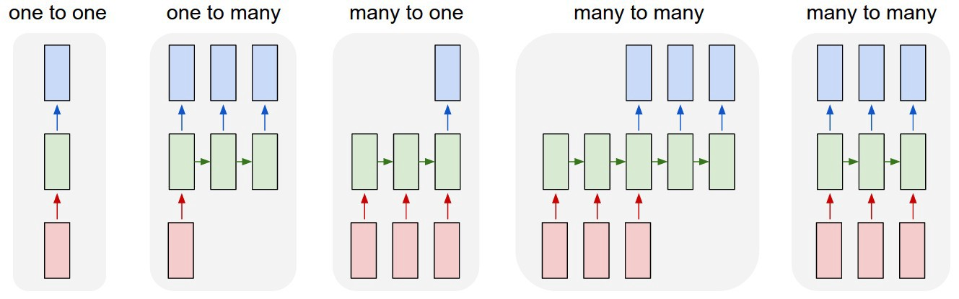

Different types of Recurrent Neural Networks.

* Image Classification
* Sequence output (e.g. image captioning takes an image and outputs a sentence of words).
* Sequence input (e.g. sentiment analysis where a given sentence is classified as expressing positive or negative sentiment).
* Sequence input and sequence output (e.g. Machine Translation: an RNN reads a sentence in English and then outputs a sentence in French).
* Synced sequence input and output (e.g. video classification where we wish to label each frame of the video)

#### The Problem of Long-Term Dependencies

##### *Vanishing Gradient*

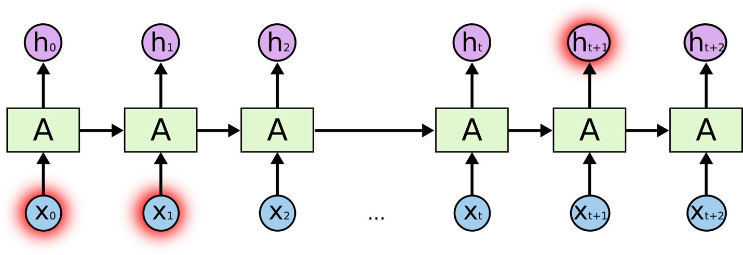

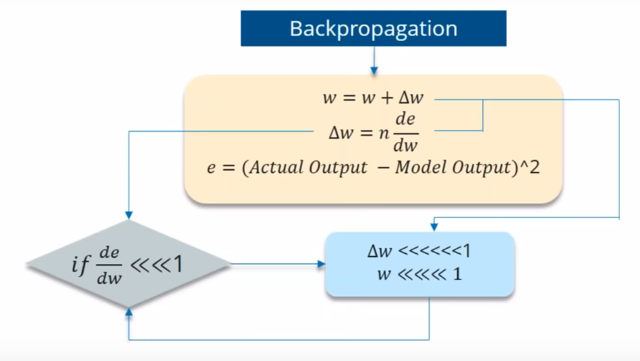

If the partial derivation of Error is less than 1, then when it get multiplied with the Learning rate which is also very less. then Multiplying learning rate with partial derivation of Error wont be a big change when compared with previous iteration.

##### *Exploding Gradient*

We speak of Exploding Gradients when the algorithm assigns a stupidly high importance to the weights, without much reason. But fortunately, this problem can be easily solved if you truncate or squash the gradients

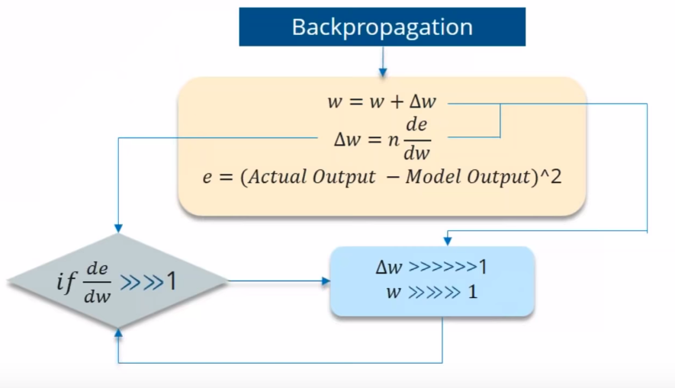

#### Long Short Term Memory (LSTM) Networks

Long Short Term Memory networks – usually just called “LSTMs” – are a special kind of RNN, capable of learning long-term dependencies.

LSTMs are explicitly designed to avoid the long-term dependency problem. Remembering information for long periods of time is practically their default behavior, not something they struggle to learn!

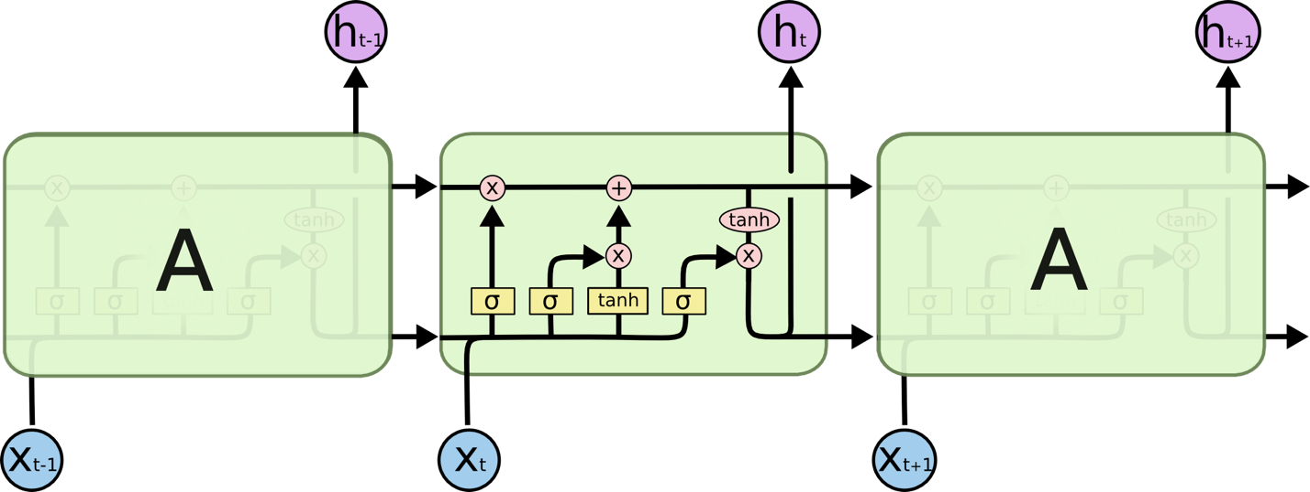

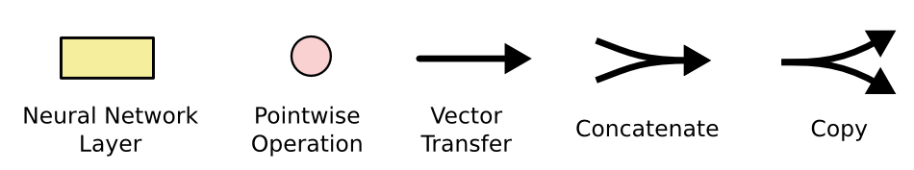

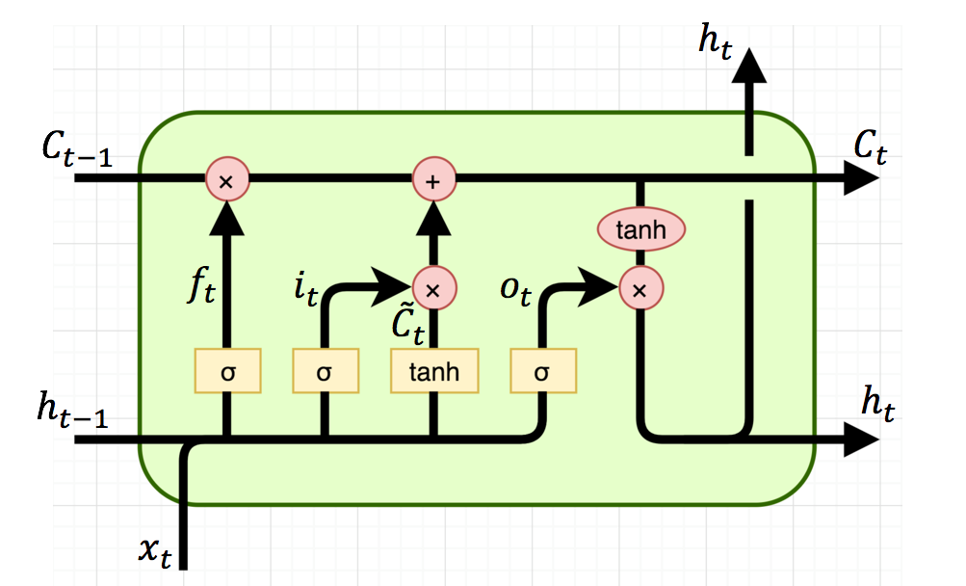

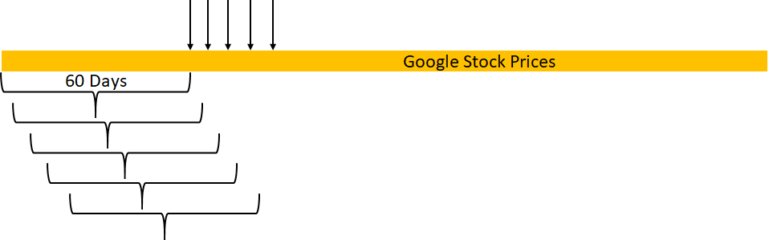

#### Steps to build stock prediction model

* Data Preprocessing
* Building the RNN
* Making the prediction and visualization